AEO “Nazarbayev Intellectual Schools”

CHEMISTRY Grade 12

Paper 2 May 2023

MARK SCHEME

Maximum Mark: 100

ANNOTATIONS AND ABBREVIATIONS

line space new marking point for same question item

/ meaning “or” indicates alternative correct responses for same marking point

( ) brackets the words or units in brackets do not need to be stated but must be implied
For example, 10 (J) means that the mark is awarded for “10” but not for “10 kJ”

underlining exact word is required

accept Indicates a less than perfect, but in this case, acceptable response.

allow identifies an answer that will be allowed if no other marking point is awarded.

not Indicates an incorrect response that would contradict another otherwise correct alternative i.e. right plus wrong penalty applies.

ignore Indicates an incorrect response which is irrelevant and does not cause a right plus wrong penalty.

ecf meaning "error carried forward",
where a wrong response in an earlier part of a question is used correctly in a later part of the same question

sig. figs Answers are normally acceptable to any number of significant figures ≥ 2.
This indicates an exception where a specified number of significant figures is required. Numbers must be correctly rounded and not truncated.

note often added for in additional guidance to help the exam marker.

con this is used when marking exam papers to indicate that a learner has given a contradictory answer and loses a mark.

ora or reverse argument

owtte or words to that effect

AVP any valid point

Question | Answer | Mark | Additional guidance | Explanation
1 (a) (i) | 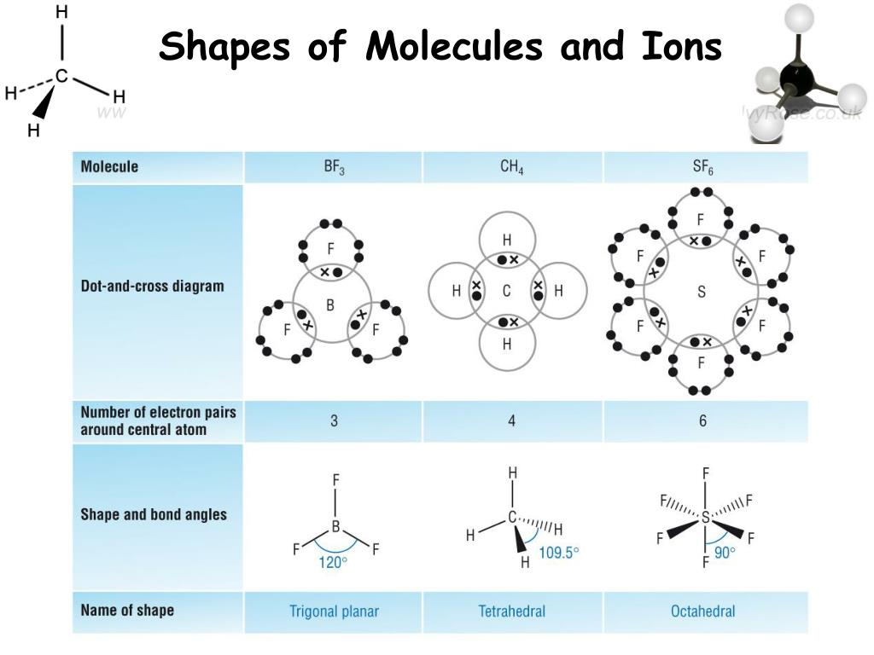 | 2 | M1 for showing 12 electrons around sulfur  and 8 electrons of fluorine atoms  M1 for correct dot-and-cross electrons
1 (a) (ii) | octahedral and 90° all angles | 2 | M1 for the shape  M2 mark for the correct angle
(b) (i) | Covalent bond is pair of electrons shared between two atoms | 1 | Sharing is the key word
(b) (ii) | the six polar bonds are symmetrically arranged /dipoles cancel each other out | 1 |  | Two explanations have the same meaning
(c) (i) | a species that donates a lone pair of electrons to the metal cation or central atom | 1 | Accept only the explanation with words: lone pair donor
(c) (ii) | dative covalent bonds/co-ordinate bonds | 1
(c) (iii) | different ligand affects to the color / another coordination number / the size of the energy gap between 3d orbitals is different | 1
(c) (iv) | [Co(Cl₄]²⁻+ 6H₂O↔ [Co(H₂O)₆]²⁺ + 4Cl⁻  Ligand exchange / ligand substitution reaction | 1  1 | Accept  without word ‘ligand’ | The equation shows exchanging of ligands, that’s why we decided to accept answers without word ligand
 |  | [Total 11]
2 (a) (i) | the energy required to remove one mole of electron  from one mole of gaseous atoms | 1  1 | Accept if student wrote correct equation for any element [1]  It is important to include state symbols [1]
2 (a) (ii) | Potassium has larger atomic radius (greater distance between nucleus and outermost electron) / less number of protons in the nucleus/smaller nuclear charge  less attraction between nucleus and the outermost electron | 1  1 | Accept if a student gives an answer with respect to bromine
2 (b) (i) | less nuclear charge of potassium ion / less number of protons in potassium ion/ less atomic number of potassium | 1 | do NOT accept less/greater distance between nucleus and outermost electron | Atomic number is the synonym of proton number
2 (b) (ii) | Atomic radius decreases across the period, because:  the positive charge of the nucleus nucleus increases/number of protons/atomic number increases across the period  the force of attraction between the nucleus and electrons increases | 1  1  1
 |  | [Total 8]
3 (a) (i) | C + O₂→CO₂  Oxidation number of carbon changes from 0 to +4  Oxidation number of oxygen changes from 0 to -2 | 1  1  1 | ecf is considered | Some candidates confused with the formulae of coal, for example as a sulfur
3 (a) (ii) | oxidising agent - oxygen  reducing agent - carbon | 1 | Accept only both answers
3 (b) | S+O₂ →SO₂  1 : 1 : 1  20 tonnes = 20 000 000 g of fuel  Mass of S= 20000000*0.005=100000 g  n(S)=100000/32=3125 moles  3125 moles sulfur produces 3125 moles of sulfur dioxide  V(SO₂)=3125*24=75000 dm³ | 1  1  1  1 | Accept  if mass of sulfur given as 32.1  ecf is considered | In the data booklet, 32.1 is given for sulfur
3 (c) | Acid rain  Lowering the pH of soil and lakes  Killing trees  Destroying of buildings  Ozone layer depletion | 1  1 | Any two of them. Accept any relevant answers. | Further research shows that sulfur trioxide affects the ozone depletion
 |  | [Total 10]
4 (a) (i) | (CH₃)₂C=CHCH₂CH₂C(CH₃)CHCH₂OH + [O]→ (CH₃)₂C=CHCH₂CH₂C(CH₃)CHCHO + H₂O/  (CH₃)₂C=CHCH₂CH₂C(CH₃)CHCH₂OH + [O]→ (CH₃)₂C=CHCH₂CH₂C(CH₃)CHCHO | 1 | Accept  only structural formulas of organic compounds | [O] is the symbol for oxidation reaction, so it is not a complete equation, it is a scheme of chemical reaction
4 (a) (ii) | from orange to green/blue-green | 1 | Ignore colour change / only meaning of green colour without mentioning orange colour
4 (b) | reflux  (CH₃)₂C=CHCH₂CH₂C(CH₃)CHCH₂OH + 2[O]→ (CH₃)₂C=CHCH₂CH₂C(CH₃)CHCOOH + H₂O  Or  (CH₃)₂C=CHCH₂CH₂C(CH₃)CHCHO + [O]→ (CH₃)₂C=CHCH₂CH₂C(CH₃)CHCOOH | 1  1 | Accept only structural formulas of organic compounds | [O] is the symbol for oxidation reaction, so it is not a complete equation, it is a scheme of chemical reaction
4 (c) (i) | Carbon-carbon double bond/ alkene | 1 |  | Meaning of alkene has the same meaning as a double bond
4(c) (ii) | 5/five | 1
4(d) | optical isomerism  Molecule has chiral atoms/assymmetric carbon atoms/four different groups or atoms (CH₃)₂C(OH)C*H(OH)CH₂CH₂C*(CH₃)(OH)C*H(OH)CH₂OH | 1  1
 |  | [Total 8]
5 (a) | C₆H₆ + CH₃COCl → C₆H₅COCH₃ + HCl | 1 | Accept only in structural or displayed formulae of products.  Do NOT accept molecular formula of the main product.
 | phenylethanone and hydrogen chloride | 1 | Accept if only phenylethanone is given.
5 (b) | electrophilic substitution / acylation | 1 |  | The question asks about the type of reaction, not the type of mechanism
 | Temperature – 60 ºC/heating under reflux | 1 | Accept  range 40-80⁰C | Candidates cannot remember precise temperature, if they understand given compounds have a low boiling point their answers would be correct
5 (c) |  | 1 | Do NOT accept  if charges are not shown.
5 (d) | 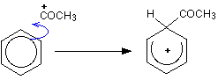  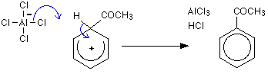  A curly arrow from benzene ring to the electrophile  For partially breaking of the delocalized electron ring in benzene molecule  A curly arrow from AlCl₄– to the appropriate hydrogen of the benzene ring  OR  A curly arrow from C-H bond of the ring to partially broken delocalized electron ring  Correct products | 1  1  1  1 |  | If a candidate doesn’t show a curly arrow from AlCl₄– to H it will not be a mistake
 |  | [Total 9]
6 (a) (i) | using catalyst to break long chain hydrocarbon to smaller hydrocarbons. | 1 | owtte
6 (a) (iі) | CH₃CH=CHCH₃ / CH₃CH₂CH=CH₂ | 1 | Accept only structural formula or displayed formula
6 (a) (iіі) | correct ion with positive charge  correct ion with negative charge and a pair of outer shell electrons  Examples  Negative charged ion (with electron pair) Positive charged ion  CH₃CH₂CH₂CH₂CH₂CH₂CH₂CH₂CH₂CH₂CH₂꞉⁻ CH₃⁺  CH₃CH₂CH₂CH₂CH₂CH₂CH₂CH₂CH₂CH₂꞉⁻ CH₃CH₂⁺  CH₃CH₂CH₂CH₂CH₂CH₂CH₂CH₂CH₂ ꞉⁻ CH₃CH₂CH₂⁺  CH₃CH₂CH₂CH₂CH₂CH₂CH₂CH₂꞉⁻ CH₃CH₂CH₂CH₂⁺ | 1  1 | If calculate carbons / hydrogens of two ions should be C₁₂H₂₆  Do not accept another molecule than dodecane for giving full 2 marks
6 (b) | Main Answer:  In our modern world low fractions like petrol in a high demand than supply from rectification of crude oil.  Due to that reason a catalytic cracking is used to obtain low hydrocarbon fractions from heavier fractions of crude oil.  Credit only 1 mark for the following one or several ideas:  for making alkenes that are monomers for making polymers / as a source of hydrogen / obtaining precursors for chemicals etc. | 1  1 | owtte
6 (c) | unpaired electron/the splitting of the covalent bond produces two free radicals/ equal splitting | 1 | Accept appropriate diagram illustration | ‘Equal splitting’ and ‘splitting of the covalent bond produces two free radicals’ have the same meaning
 |  | [Total 7]
7 a (i) | –OH in alcohols/ hydroxyl group in alcohols | 1
7 a (ii) | Water also has –OH group | 1
7 (b) (i) | Peak a is –OH  Peak is b –CH₂-  Peak is c –CH₃ | 1  1  1  Max [2] | M2 – for three correct answers  M1 – for two correct answers
7 (b) (iі) | Peaks always split into the number of hydrogens on the neighbouring/adjacent carbon(s), plus one. | 1 |  | Adjacent and neighbouring have the same meaning
7 (c) | The peak with respect to –OH group disappears / would be two peaks only | 1
7 (d) (i) | m/z=29, corresponding ion is CH₃CH₂⁺ / C₂H₅⁺  m/z=45, corresponding ion is CH₃CH₂O⁺ / C₂H₅O⁺ | 1  1 | Do NOT accept without charge
7 (d) (ii) | Relative molecular mass of the compound/ molecular ion peak | 1 | The answer is accepted if the word ‘relative’ is missed. | Both answers should be accepted since both are correct
 |  | [Total 9]
8 (a) | conc. sulphuric acid  reflux/heat | 1  1 | Accept, only concentrated sulfuric acid
8 (b) | H₂N-C₆H₄-COOCH₂CH₃ | 1 | Accept only structural formula or displayed formula
8 (c) (i) | ester,  amine,  benzene ring | 1  1  1  [Max. 2] | M2 – for three correct answers  M1 – for two correct answers
8 (c) (ii) | ethyl-4-aminobenzoate | 1 | do NOT accept 4-amino-ethyl-benzoate
8 (d) (i) | H₂N-C₆H₄-COONa + CH₃CH₂OH | 1 | M1 for both correct products
8 (d) (ii) | The reactions are one-way rather than reversible  The products are easier to separate. | 1  1
 |  | [Total 9]
9 (a) (i) | H₂O + H₂O↔ H₃O⁺ + OH⁻ | 1
9 (a) (ii) | Bronsted-Lowry acid is a proton donor  Bronsted-Lowry base is a proton acceptor | 1  1
9 (a) (iii) | OH⁻/ hydroxide ion | 1
9 (b) (i) | CH₃COOH↔ CH₃COO⁻ + H⁺  Or  CH₃COOH + H₂O ↔ CH₃COO⁻ + H₃O⁺ | 1 | Do NOT accept  without sign of equilibrium
9 (b) (ii) | partially\slightly dissociate in water and produces hydroxonium ions or free protons. | 1
9 (c) | Ka = [ CH₃COO⁻][ H⁺]/[CH₃COOH]  pKa = –log₁₀(K_{a}) = 4.74  [H⁺] = √ 1.8*10⁻⁵ × 0.10*10⁻³ = 4.24 × 10⁻⁵  pH= –log [4.24 × 10⁻⁵] = 4.37 | 1  1  1  1 | Do NOT accept  if an answer is not in two decimal places.  Accept e.c.f.
9 (d) | H₂SO₄→2H⁺ + SO₄^{2–}  [H⁺] = 2×0.10=0.2 mol×dm⁻³  pH = –log [0.2] = 0.70 | 1  1  1 | Give three marks if answer is correct with two decimal places  Give two marks if answer is 1.00 and H₂SO₄→H⁺ + HSO₄–  Give one mark if answer is 1.30 | Many candidates show H₂SO₄→H⁺ + HSO₄– equation, but calculation algorithms should be correct.
 |  | [Total 13]
10 (a) | the powdered solid has a greater surface area  the faster the rate of reaction  because more collisions will occur | 1  1  1  [3] |  | Question not considered ‘with the same mass’ answer. Faster reaction = more collision
10 (b) (i) | Two marks:  Order of reaction with respect to A - 0  Order of reaction with respect to B - 1  Order of reaction with respect to C - 1  One mark:  Overall order of reaction = 2 | 2  1  [3] | M2 – three correct answers  M1 – two correct answers
10 (b) (ii) | Rate = k [B][C] | [1] | ecf
10 (b) (iii) | k = 0.014  mol^{–1} dm³ s^{–1} | 1  1  [2] | ecf
 |  | [Total 9]
11 (a) | (CH₃)₃CNH₂ + NH₄⁺Br ⁻/(CH₃)₃CNH₂ + HBr | [1] | Organic compounds should be in their structural formulas. | NH₄Br and HBr products can be formed at the same time in the reaction mixture
11 (b) (i) | It ensures that all the halogenoalkane molecules react with the ammonia to produce a primary amine. | 1
11 (b) (ii) | a sealed tube / heating / ethanol as a solvent/ alcoholic solvent | 1
11 (c) | nucleophilic substitution reaction/ SN | [1] | Do NOT accept  if only substitution reaction is given | Candidates may use abbreviation (SN = nucleophilic substitution)
11 (d) | 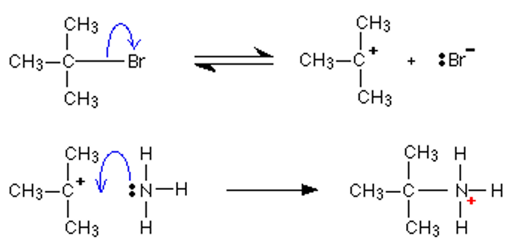  A curly arrow from the C-Br bond to the bromine atom  A curly arrow from the lone pair of ammonia to the (CH)₃C⁺ carbocation  For all correct charges and lone pairs (on nitrogen and bromide ion) | 1  1  1  [3] | Credit only for all correct charges and lone pairs (on nitrogen and bromide ion)
 |  | [Total 7]

BLANK PAGE

